**Change password test case**

**Goal:**

As a tester, I want to verify if the Change Password form works correctly to show if the formulary is appropriately filled.

**Background:**

Change Password page is responsible for changing a password to a different one required by the user.

**Steps to Reproduce**

1. Go to <https://www.find-a-house.nl/en/home> and click on the menu bar.

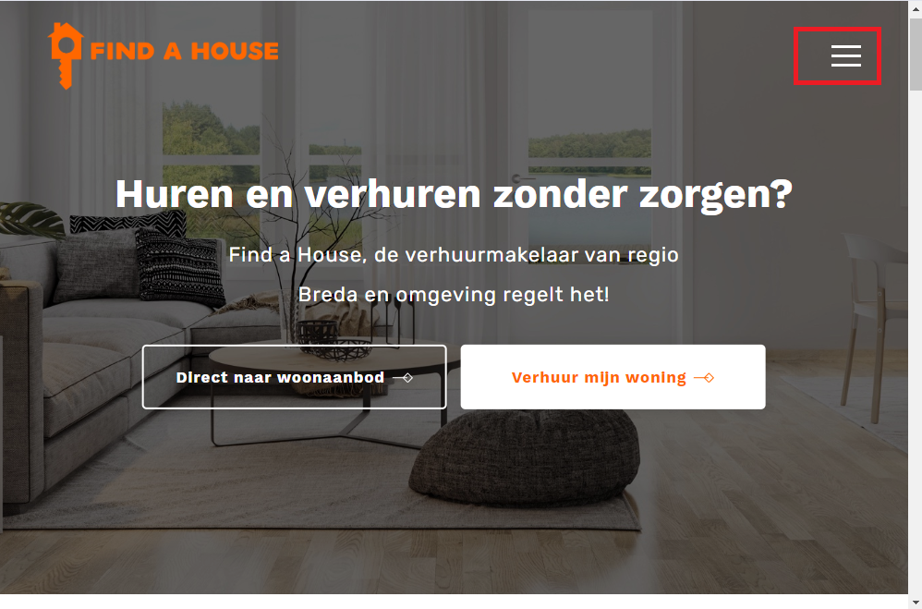

2. Click on the “Inloggen” Button to open the Login form.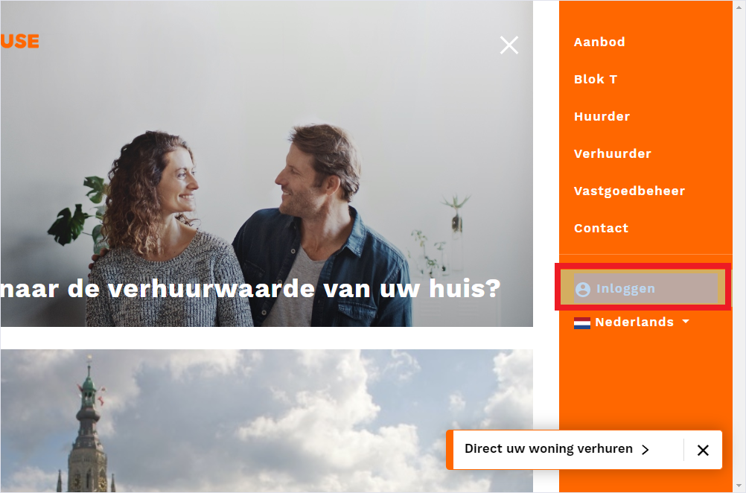

3. Type an email account, password and click on the button “Inloggen” 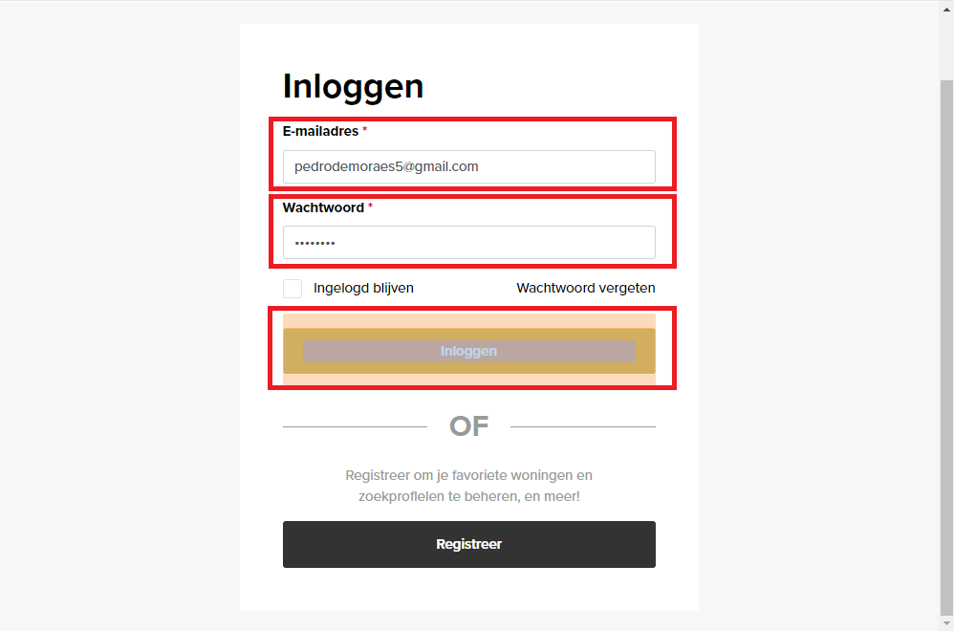

4. After effectuating Login, click on the “My gegevens” button.

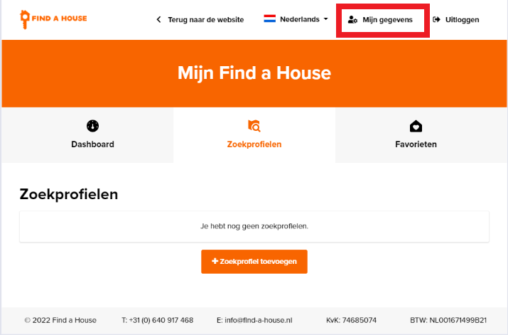

5. Open the Personal Data Page then click on the button “Wachtwoord veranderen.”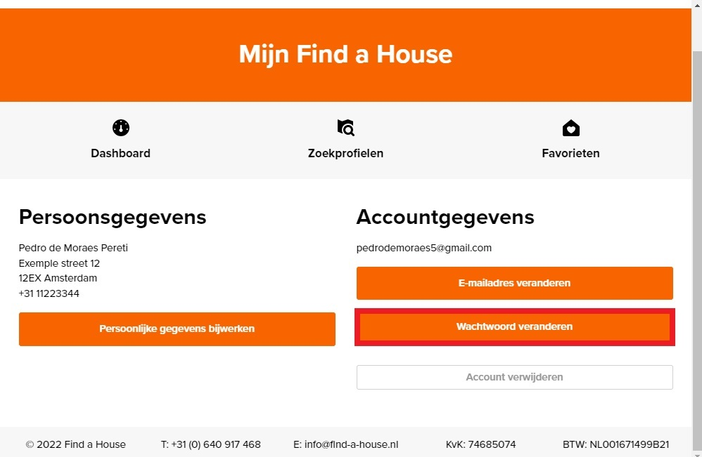

7. Fill the form with correct information, click again on the button “Nieuw wachtwoord opslaan”.

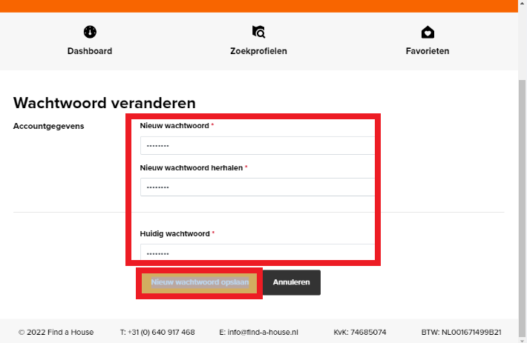

8. The procedure is finished and the page is redirected to My Details.

